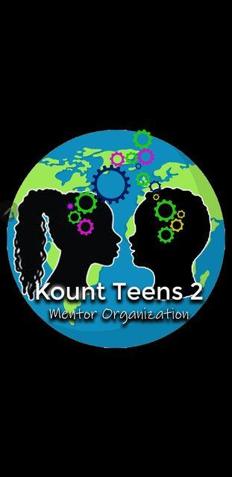

WHO AM I
Hello! My name is Jonee’ Williams, Founder and CEO of Kount Teens 2 Mentoring Organization. Over the years , I saw a need for a mentoring program in our community that offers year-round assistance to at risk youth ages 12-18 years old (boys and girls) and as a result, Kount Teens 2 Mentoring Organization was created. I’ve previously worked in the school system, juvenile justice system and foster care with youth throughout northeast Louisiana which has allowed me to develop relations. These relations have led me to wanting to be part of the solution for a change in my community. It is with great honor I introduce to you Kount Teens 2 Mentoring Organization.
WHO ARE WE
Kount Teens 2 Mentoring Organization is a 501(3) c, non-profit organization headquartered here in Monroe, Louisiana. We have been established since 2019.The purpose of our organization is to instill hope, provide guidance, and equip our youth with life skills that will be sufficient in promoting growth and the development of healthy choices as they prepare to face life’s challenges. We offer youth new strategies for facilitating productive dialogue about various issues in the community and the world. It is our goal to serve as instructors by sharing knowledge and tools that will assist our youth in navigating successfully through life’s journeys.
Our Mission Statement: Kount Teens 2 Mentoring Organization is dedicated to promote healthy lifestyles; civic responsibility; and encourage healthy relationships for youth.

Our Motto: Changing Lives One Teen At A Time
Our Vision is to ensure the establishment of quality teenagers built on principles of trust, respect, accountability, responsibilities, fairness, and equality that will empower change and instill a lasting impression of change in our community, as well as, in the world.

WHAT WE DO
On May 4, 2024 we will be hosting our fundraiser “Walk A Mile In Our Shoes.” This fundraiser is in support of Lupus Awareness Month This will be a family fun filled event with live music and impactful information on this devastating disease. Our goal is to advocate awareness, show support, as well as bring recognition to the many lupus warriors in our community who are living with this mysterious disease. We have found that this event is well needed and for this event to be a great success your help is greatly needed! Details on registration and participation are below. Thank you in advance for your support!
Jonee’ Williams/Founder
Email: joneewilliams@kountteens2.org
Phone: 318-602-0902 EXT.1
1K Walk Registration

Individual packet- 25.00 Certificate of participation, 2024 T-Shirt

SPONSORSHIP TYPE*:
Platinum
$1,000 Social media advertisement mentioned as a sponsor, web page advertisement http://kountteens2.org for a year (includes business information), T-Shirt with logo, plaque
Bronze
$ 500-800.00 Social media marketing as our sponsor with logo, vendor set up at two events, plaque and T-shirt
Gold
$100- 400.00 Social media advertisement as our sponsor, advertisement at events, T-Shirt with logo
Donations Type:
( ) $80
( ) $40
() $20
() $10

Jonee’ Williams/Founder
Email: joneewilliams@kountteens2.org
Phone: 318-602-0902 EXT.1

Make all checks payable to: Kount Teens 2 Mentor Organization
CashApp: $kt2mentorsorg
Square: Kount Teens 2 Mentor Organization
Venmo: KT2Mentors

Print Business/ Individual Name:
Phone Number:
Signature:
Sponsor Level/ Donations Type/ Amount:
T-Shirt Size
For Office Use (Circle One): Payment: Cash CHK MO
Graphics Attached: Y N
Lupus Warrior: Y N Do you have a person that you would like recognized Y N
Please provide their name:

**This agreement authorizes Kount Teens 2 Mentoring Organization to place a banner or sign advertising your business on promotional items at events. The banners or signs will be placed at our discretion and will be placed prominently. These banners and signs will have a uniform design with all your pertinent information properly dissolved

